MSc Literature review

Farbod Fahimi refers to autonomous aerial vehicles as “intelligent aerial vehicles that are able to fly with minimal to no human interaction” (Fahimi, 2009). Meanwhile George A. Bekey, similarly refers to autonomous robots as “intelligent agents” that, through their definition of a robot, is “a machine that sense, thinks and acts” hence the term agent (Bekey, 1998).

Autonomous drone which are both robots and autonomous, would therefore, need the tools and infrastructure to sense, think and act, allowing them to fly with minimal human interaction. Intelligence is a vital part of an autonomous robot and since information comes from data while intelligence comes from information (Haissam, 2022), being able to gather information and recognise objects through repeated training with machine learning algorithms will only be possible with the help of data.

It is well understood from literature that the performance of a machine learning model is upper bounded by the quality of the data (Jain et al, 2020). Where we want a reliable autonomous drone to operate safely around humans and for the sake of not being invasive, it is vital that as much data as possible is collected, as the consequences of a wrong face recognition classification due to poor data could result in instilling fear in members of public or the drone not being able to accomplish an objective.

While Researchers and practitioners have focused on improving the quality of models (such as neural architecture search and automated feature selection), there are limited efforts towards improving the data quality (Jain et al, 2020). And since this research project will be making use of well tested and renowned face recognition algorithms that will have highly optimised models, the data stands out as the most important aspect of this project.

Good machine models require accurate data to act on. The project goal and type of data pertains to the choice of machine learning algorithm that best suits the data. The quality of the model’s result is a fundamental factor to take into account when choosing a model. It is important to prioritise algorithms that maximize that performance (Santiago, 2021).

Depending on the problem, different metrics could be useful to analyse the results of a model. For example, some popular metrics include: accuracy, precision, recall and f1-score (Santiago, 2021).

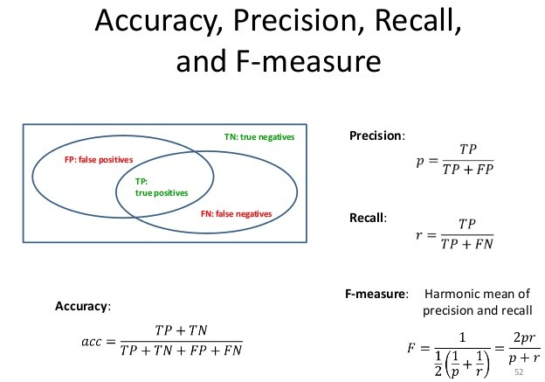
As the focus of this project on Face recognition, the most important metric to consider is the classification accuracy. This metric is defined as the number of correct predictions divided by the total number of predictions.

Aside from the classification accuracy, Precision is another good indicator to monitor the performance of a classification algorithm(Santiago, 2021). Cases where classification accuracy fall short include: when a class has a distribution imbalance, meaning one class is more frequent than others, i.e., there are more images of one person in a dataset than others. Given such a case, even if all samples are predicted as the most frequent class, the model would still return a high accuracy rate, and this does not make sense because the model would not be learning anything. IT would simply be predicting everything as the top class. An example of this in the scope of this project would be the face recognition algorithm predicting everyone it sees as the same person or detecting a face when there is no face in frame.

To mitigate this, the precision metric is calculated as true positives/ true positives + False positives). This metric is especially significant when handling classification algorithms such as the Haar cascade algorithm that is prone to False positive classification (Shervin, 2019).

Recall, F1-score and Sensitivity and specificity are other metrics that will be considered for the face recognition aspect because Recall is defined as the fraction of samples from a class which are correctly predicted by a model. This will determine the overall reliability of the models being used for this project as a higher Recall value shows that the method is not biased in classifying detected faces or when it comes to face recognition.

F1-score is defined as the harmonic mean of the Recall and Precision metric and it is important when we want to measure both Recall and Precision equally because there is a negative correlation between Precision and Recall.

Sensitivity and Specificity are the last to be considered because Sensitivity is synonymous with Recall and Specificity is defined as the number of true negatives / (true negatives + false positives).

While machine learning places a significant role in this project. “At this level of autonomy, it requires vehicles to sense the surrounding environment like humans, such as distance of obstacle, signalization, location, moving pedestrians, etc., as well as making decisions like humans.” (Weijing Shi, 2017). This list of necessary features helps to create a list of corresponding sensors that would be required on an autonomous drone.

The list also helps to formulate a list of key challenges for the project:

How the autonomous drone sense the surroundings like humans?
How will the drone localise itself?
How will the drone detect moving pedestrians?
How will the drone signal what it is doing?
How will the drone make decisions?

References:
Fahimi, F., 2009. Autonomous robots. Modeling, Path Planning and Control.

Bekey, G.A., 1998. On autonomous robots. The Knowledge Engineering Review, 13(2), pp.143-146.

Malak, H.A.,2022. What is information intelligence? Why is it important?

Jain, A., Patel, H., Nagalapatti, L., Gupta, N., Mehta, S., Guttula, S., Mujumdar, S., Afzal, S., Sharma Mittal, R. and Munigala, V., 2020, August. Overview and importance of data quality for machine learning tasks. In Proceedings of the 26th ACM SIGKDD International Conference on Knowledge Discovery & Data Mining (pp. 3561-3562).

Valdarrama. S., Considerations when choosing a machine learning model.

Minaee, S. 20 Popular Machine Learning Metrics. Part1: Classification & Regression Evaluation Metrics

Shi, W., Alawieh, M.B., Li, X. and Yu, H., 2017. Algorithm and hardware implementation for visual perception system in autonomous vehicle: A survey. Integration, 59, pp.148-156.

